**How to Deposit Kenyan Shilling (KES) on Golix**

Assuming you have already logged in to your account, kindly follow these simple steps:-

* Click on your KES Wallet as indicated in the diagram below



* Click on the Deposit Tab and fill in how much you want deposit and click on **CHECKOUT WITH DUSUPAY,**  as shown in the diagram below.

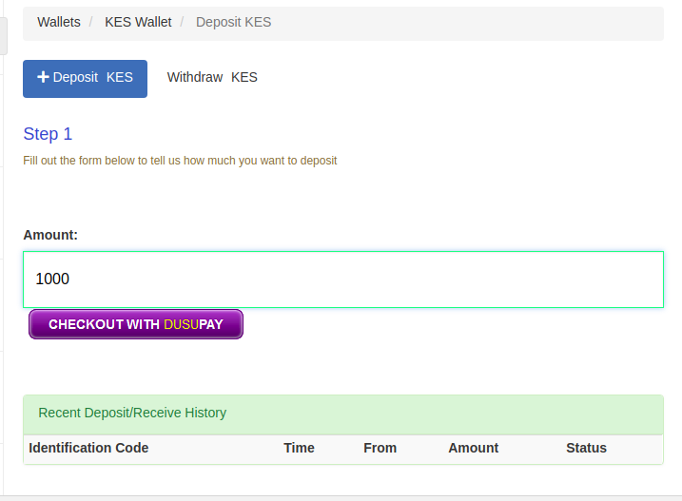

* Select your payment option from the list that you wish to use e,g Mpesa Mobile Money or Kenya Local Cards.
* Fill in your details eg Phone number, name , Email (optional).
* Each time you make a deposit make sure it appears on you Transaction History.